**2018BTECS00061**

**2019BTECS00202**

**ASSIGNMENT NO:1 Date:20/3/2021**

* **Title:**

Installation,configuration and testing of Oracle 18*c* Express Edition.

* **Objective :**

Downloading Oracle sever and Client and demonstarting CRUD operations on selected table.

* **Introduction :**

To install the Oracle Database software Oracle Universal Installer (OUI) is used. OUI is a graphical user interface utility that has following features:

* + Automatically launches software after installation
  + Install new Oracle Database software
  + An XML based centralized inventory

OUI will start the Oracle Database Configuration Assistant (DBCA) while the installation process is on, which will install a procreated default database that can take you through the process of creating a customized database or shows example schemas.

If you do not create a database during installation, you can invoke DBCA after you have installed the software, to create one or more databases.

**Hardware and Software Requirements**

Several automated checks are being performed by OUI before installing the software, to make sure that your computer satisfies the need of basic hardware and software requirements for an Oracle Database installation. If your computer is not upto the requirements, an error message pops up. The requirements to install the software are:

* + 2 GB of physical memory minimum
  + Sufficient virtual memory (swap)
  + Minimum 10 GB of free disk space
* **Database Server:** Oracle 18c ,MySql 8.0
* **Programming Language:** Python
* **Procedure :**

**1. Downloading oracle database software**

After downloading the files, use tools such as 7-zip,win-zip or the default built-in extraction tool provided by Windows to extract the .zip files. In this OBE, we have used the 7-zip tool to extract the software files.

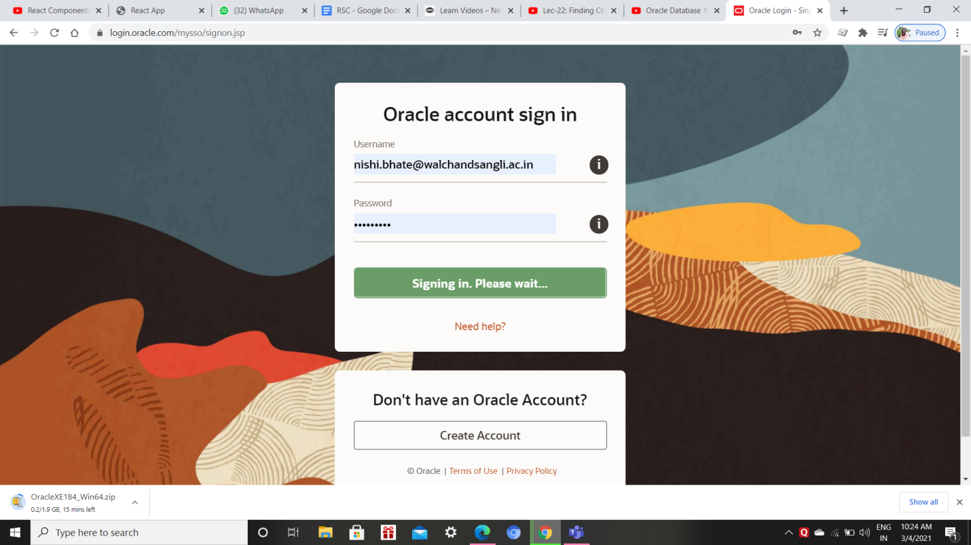

**2.The extracted files are here:**

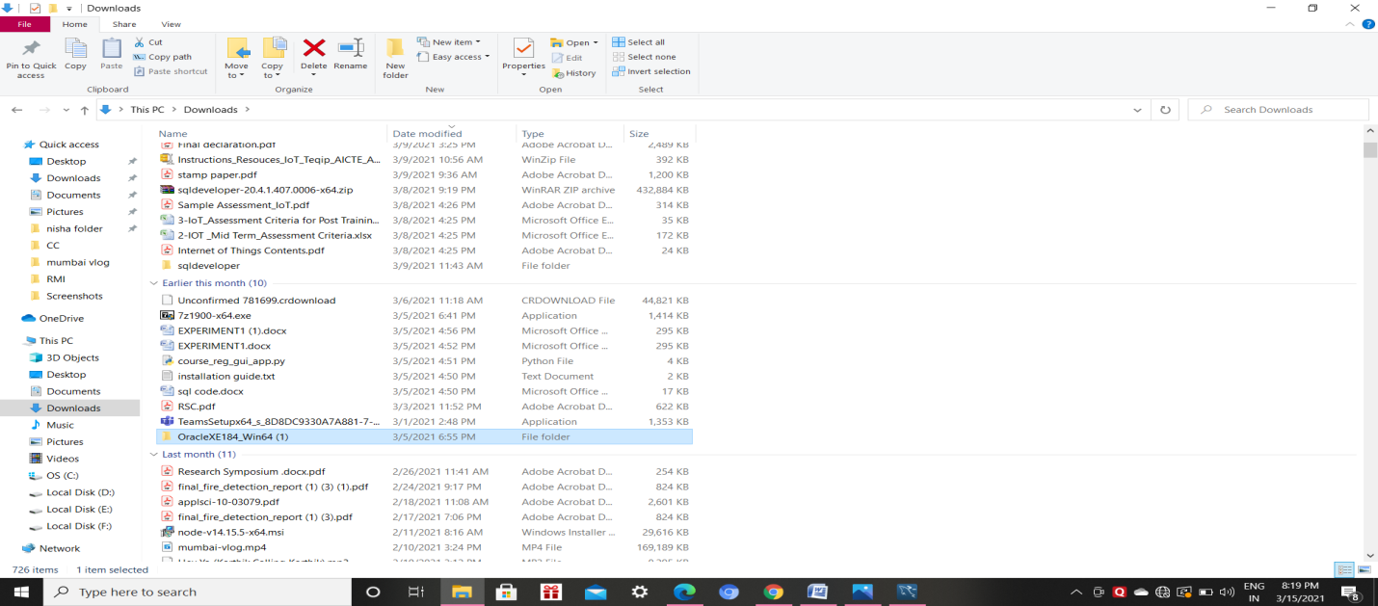

**3.Create and configure a single instance database.**

**4.In this step, you have to choose between Server Class and Desktop class.**

**Desktop class:** If you are installing this oracle database 18c on your laptop or desktop then go with this option.

**Server class:** If you are installing it on a server which is capable of handling the load of all the server components and processes then choose this option.

1. **Oracle Installer** creates 13 **Windows user groups** for doing various tasks such as handling security, taking care of user privileges and running Windows services for Oracle Database. To handle these groups Oracle server needs a **dedicated Windows User**.

**Installation:**

**Database Edition**: Here you will get a drop-down menu with the list of all the database versions available with your download. As mentioned above, our download comes with both the version of Oracle Database 18c which are, Enterprise Edition and Standard 2 Edition. Choose either of them accordingly. I suggest you to go with Enterprise Edition.

**Character Set**: Let it be on its default value.

**Global Database Name (S.I.D.)**: The Global Database Name will be the name of your database and will serve as your database SID. You will need it while making a connection with your database using tools such as SQL Developer. By default, it is set as ORCL. If you want, you can change it to any other name, but make sure to remember it. I suggest you write it down somewhere as your Database SID.

**Password**: This will be the password of your administrative users such as sys or system.

**Create as Container Database**: Here you will get a checkbox. If you check this box then OUI will create a container database for you.

**Pluggable Database Name**: Here you have to specify a unique name for your pluggable database. For this demonstration, I am good with the default name.

1. **Prerequisites:** In this step, the OUI will check the prerequisites. If everything goes well then we will be good to install it. If there is any error then the OUI will show you .

Once the installation is done the installer will show you the URL for your Oracle Database 18c Enterprise Manager. Enterprise Manager is a web-based tool for managing Oracle Database 18c.

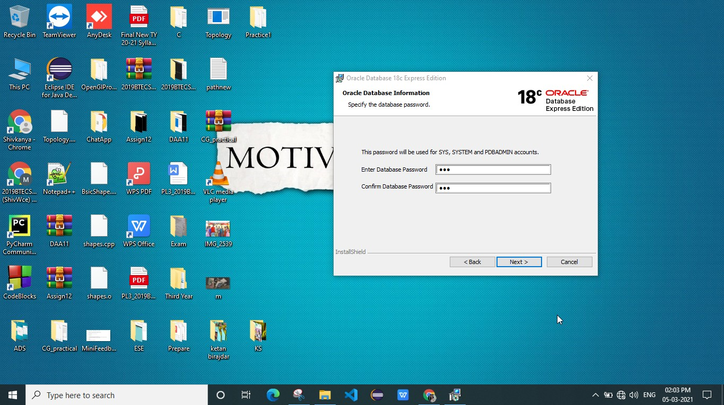

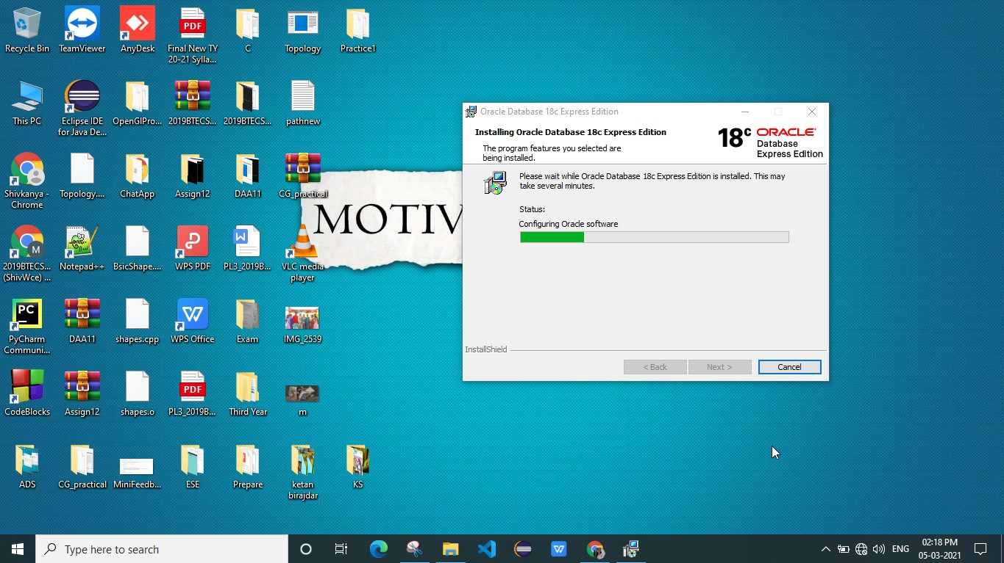

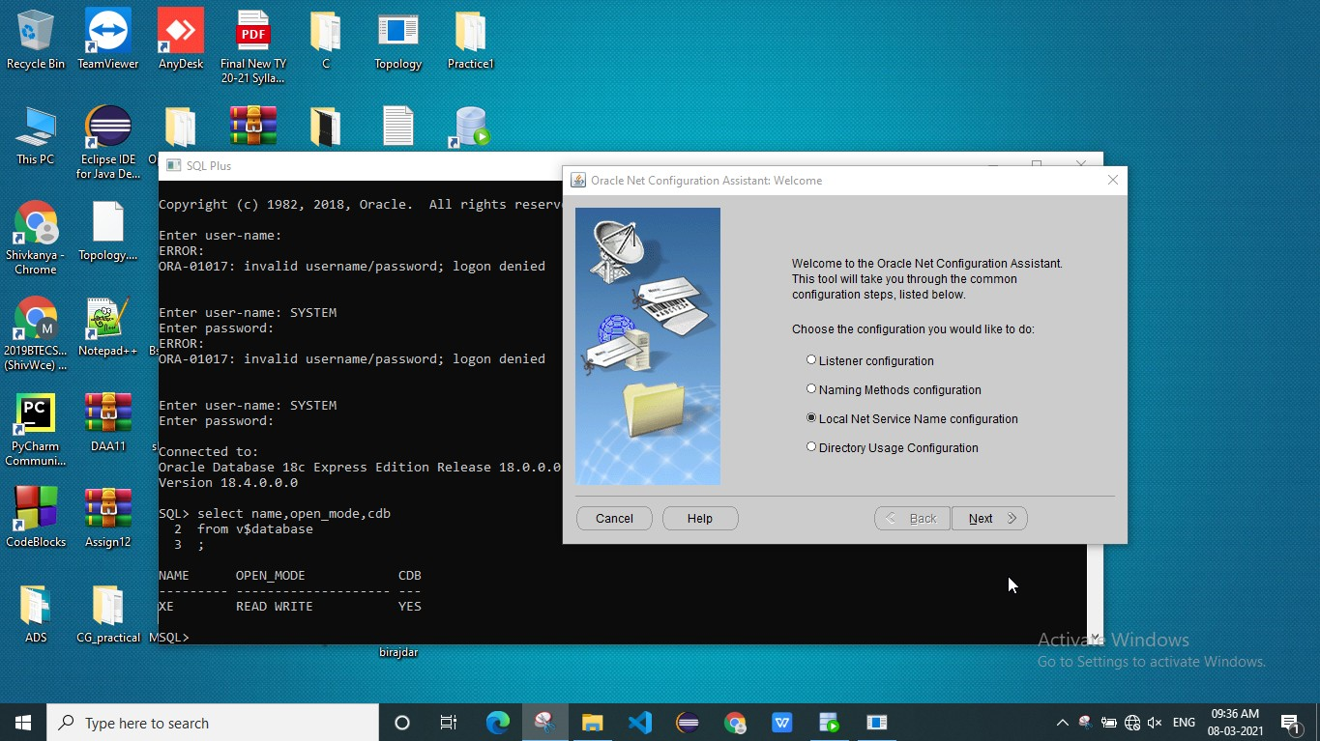

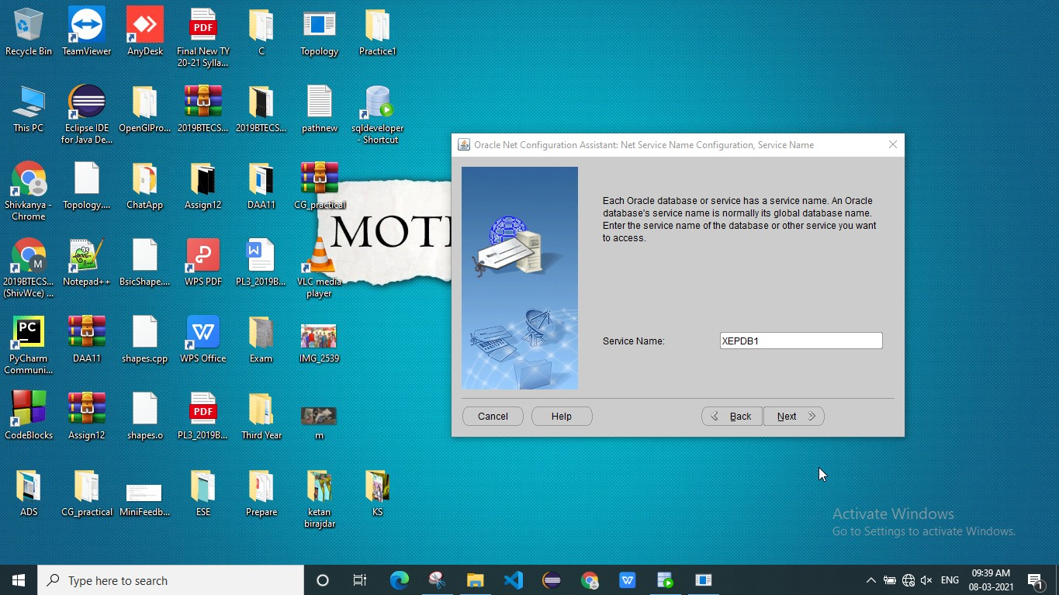

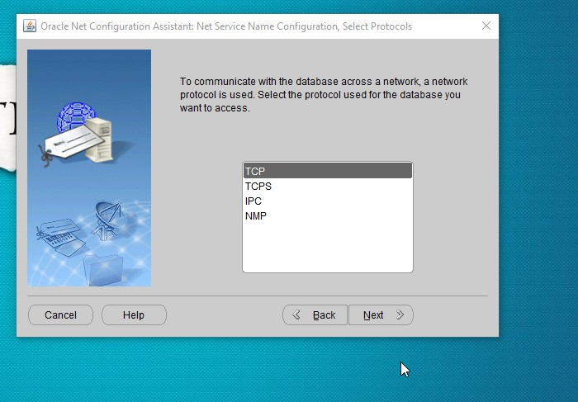

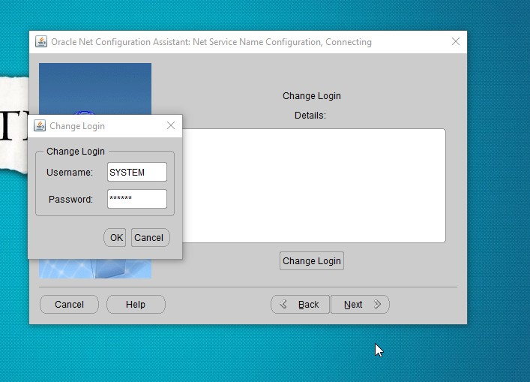

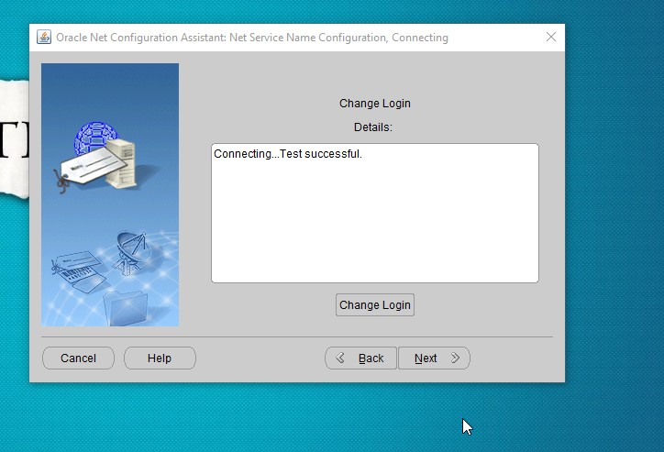

**Result:**

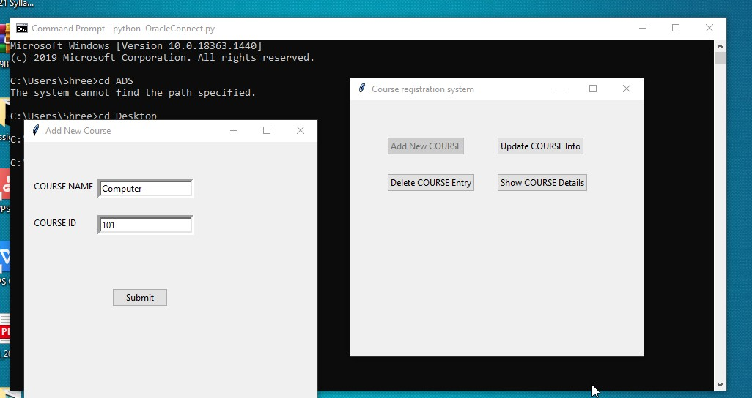

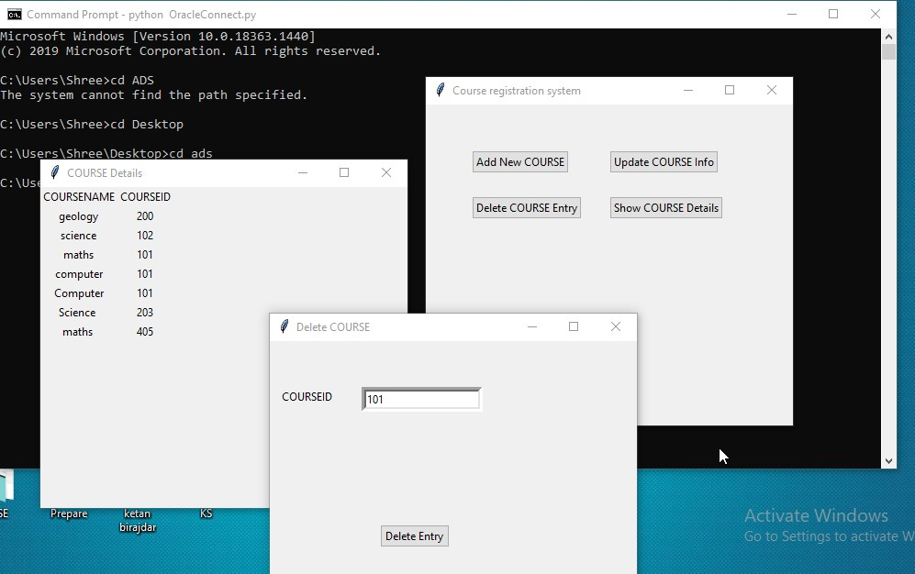

* **Conclusion** .

Python can connect to oracle using a python package called cx_Oracle. Oracle is one of the famous and widely used database and python’s data processing features

* **References :**

1. <https://www.geeksforgeeks.org/oracle-database-connection-in-python/>
2. <https://www.youtube.com/watch?v=vR5utJvN4JY>  
   3)[Database Software Downloads | Oracle](https://www.oracle.com/database/technologies/oracle-database-software-downloads.html)